5/5/2025 OS-A and B
Q1-Consider a paging system where the frame size is 32 KB, and Main Memory size be 256 MB and Virtual Memory of 512MB. Answer the following questions:
i. How many total numbers of pages are ?
29 bit
pagenumber: 29-15=14 -2^14
ii. How many bits will be required for the page size and offset?
pagesize: 15
iii) What is size of Logical Address Space?
512MB = 2^9.2^20 = 2^29 29 bits

iv) What are the max number of Frames ?
28bits
Framenumber = 28-15 = 13 =2^13 =>
FrameSize= 32KB= 2^5.2^10 = 2^15= 15

v) What is size of Physical Address Space?
256MB = 2^8.2^20 = 2^28 28 bits

vi) Compute the size of the page table if each page table entry also required 4 additional bits (valid, protection, dirty, use).
Total number of Enteries * size of Each Entry
2^14 *(13+4)
2^14* (17)=3 bytes
2^14*3
vii-Take logical address and below page table, Translate logical address to physical Address .
Logical Address=197122 = >29

00000000000110 000001000000010
Page Number | Frame Number
0 | 5
1 | 9
2 | 12
3 | 4
4 | 7
5 | 1
6 | 15
7 | 18

page number 6 holds 15 Frame number. Convert 15 into 13 bit binary(Framenumber bits)
0000000001111 000001000000010 => 492034
Q2
Consider a system with memory mapping done on a page basis, and using a single level page table. Assume that the necessary page table is always in memory.

(a) If a memory reference takes 100 nanoseconds, how long does a memory mapped reference take if there is no TLB within the MMU to cache recently used page addresses?

(b)Now we add an MMU which imposes an overhead of 15 nanoseconds on a hit or a miss. If we assume that 90 percent of all memory references hit in the MMU TLB, what is the Effective Memory Access time?

(a) 100ns for accessing the page table + 100ns for accessing the data = 200ns. (b) There are two cases. In the first case, the TLB contains the required entry. Then we pay the 15 ns overhead on top of the 100 ns memory access time. In the second case, the TLB does not contain the item. Then we pay an additional 100 ns to get the required entry into the TLB, making 215 ns altogether. Hence, the EMAT is: (115 * 0.9) + (215 * 0.1) = 125 ns
115 * 0.9 - Hit
215 * 0.1- Miss
Q3- Consider a computer system with a 32-bit logical address and 4 KB page size. The system supports up to 512 MB of physical memory. How many entries are there in:
a. A conventional single-level page table?
b. An inverted page table?
32-12= 20 2^20
4Kb= 2^2.2^10 = 12 bits
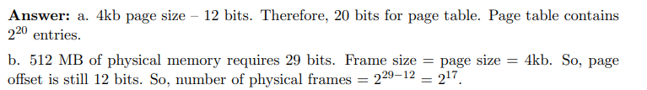
Q4- In a 32-bit machine we subdivide the virtual address into 3 parts as follows
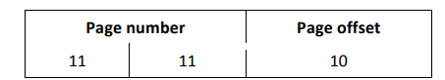
We use a two-level page table (in memory) such that the first 11 bits of an address is an index into the first level page table and the next 11 bits are an index into a second level page table. Each page table entry is 64 bits in size.
How much space is occupied in memory by the page tables for a process that has 128MB of actual virtual address space allocated? Show your work with detailed explanation. (5 points)
2^7.2^20 = 2^27
page size = 10
page number = 17 = 2^7.2^10 = 128K

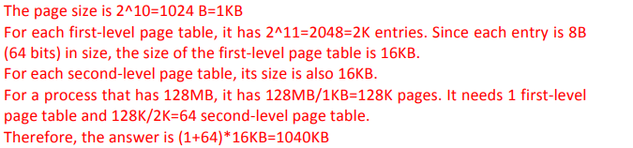

Q5-Consider a system with 3 physical frames of memory that is given the following page memory reference sequence: 1, 3, 6, 7, 1, 3, 6, 7, 1, 3, 6, 7 What is the number of page faults that would occur for each of the following page replacement algorithms?
a. An optimal page replacement algorithm
b. LRU

